<DATE>

Dear <Name of boss or professor>:
I would like to express my desire to attend the 2023 Coca-Cola Scholars Leadership Summit in Atlanta, GA, September 7-10, and how it would be beneficial to our team and my professional development.
During my senior year of high school, the Coca-Cola Scholars Foundation selected me from among a pool of more than 90,000 applicants from across the country based on my commitment to leadership, service, and making a positive impact in my community. Today, there are over 6,750 Coke Scholars who are visionary leaders and change agents around the world, including members of the US Congress, Fortune 500 presidents, Emmy award-winners, Broadway stars and playwrights, Miss Americas, Nobel Peace Prize winners and more, and I am honored to be among them.
The Coca-Cola Scholars Leadership Summit is a special opportunity for all Coke Scholars from around the world to gather every five years in Atlanta. This conference will provide exclusive opportunities for networking with some of the most accomplished professionals from around the country and unique learning experiences for personal and professional growth.
The conference is relevant to my professional goals because <state your reasons/goals >.
Attached is a document detailing what I can expect, and a breakdown of estimated costs related to my travel and participation in this event. I am also happy to share with you the Leadership Summit website which provides more details, including testimonies from attendees of past Summits. http://summit.coca-colascholarsfoundation.org/
I would greatly appreciate the opportunity to attend the 2023 Coca-Cola Scholars Leadership Summit. I am confident you will find my participation in this event a worthwhile and wise investment that will pay off for years to come.
Sincerely,
<signature>
<first and last name>
Enclosure:
– What to expect and Breakdown of estimated costs

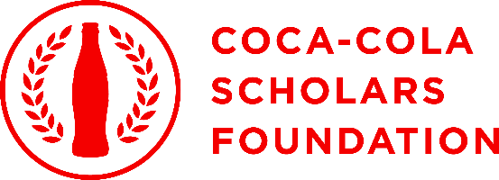

Coca-Cola Scholars Leadership Summit
September 7-10, 2023
Atlanta, Georgia

Unleash Your Magic

Two things unite all Coke Scholars: their passion to make the world a better place and the magic they felt when they learned that Coca-Cola would change their life forever. Each bottle, can, or jingle is a reminder that Coca-Cola believed in them – Coca-Cola saw their magic.
At this fourth Leadership Summit, 35 classes of Scholars will return to Atlanta to rediscover their own magic as visionary leaders. Programming will help Scholars discover how to put purpose to their work, make that purpose tangible, and create a ripple effect, encouraging inspired work within their teams and beyond. Beyond the individual, the Summit will unleash the incredible magic that happens when Coke Scholars come together as a powerful force for good in the world.
What else can you expect? As a 2023 Leadership Summit attendee, you will be:
- CONNECTED | Meet and network with the Coke Scholars network, which includes some of the brightest and most innovative leaders in the country, the Coca-Cola Scholars Foundation, and the Coca-Cola system
- INSPIRED | Refresh your passion to do good in the world! Experience an opportunity of personal and professional growth and learning.
- ENGAGED | Collaborate and innovate with fellow game-changers to make your ideas to change the world a reality.

Estimated Costs for the 2023 Coca-Cola Scholars Leadership Summit in Atlanta, GA:
Registration:
$425 before July 5
$500 after July 5

Flight:
<Fill in depending on where you’re coming from or remove if driving>

Ride Share Costs
<Fill in as needed >

Hotel Accommodations:
$199 + tax a night if staying at the Summit hotel, The Starling Atlanta Midtown.

Hotel Parking:
Valet daily: $41, Valet overnight: $62, Valet oversize overnight: $72 <Remove if not needed>

Dining:
Most meals are included in the Summit registration fee.

Total estimated cost per person: $1500 <you edit once you factor in flight/ car rental/parking> or (you edit) if no flight/car rental.

Total estimated cost for CCSF per person: $2100

